Example of a Header:

{BEGIN enter member information}
- Librarian→ enters member’s name
- Librarian→ enters member’s address
- Librarian→ enters member’s phone number
{END enter member information}

Note that Header names are always the same in opening and closing tags

Hierarchy of Headers and Actions:
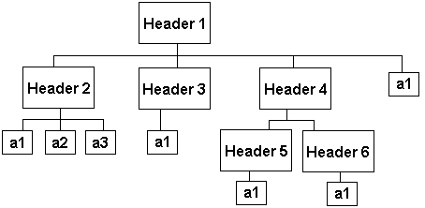
Note: A header may either contain other headers or just action. A header CANNOT contain both sub headers and actions

Example Basic Flow:

Basic Flow:

{BEGIN Use Case}

{BEGIN present price list}
- SYSTEM→ presents the different sections that exist in the arena and the price for a single seat in each section
{END Present Price List}

{BEGIN enter ticket order information}
- Customer→ selects the desired game from the team’s calendar
- Customer→ enters the desired section
- Customer→ enters the number of tickets
- Customer→ submits order request
- PERFORM search tickets
{END enter ticket order information}

{BEGIN purchase ticket}
- SYSTEM→ prompts the Customer to accept or reject the offered seats
- Customer→ accepts to purchase ticket
- INCLUDE Perform Transaction
{END purchase ticket}

{END Use Case}

Note: The Basic Flow Section is always enclosed with the special tags of {BEGIN Use Case} and {END Use Case}

Example Alternative Flow:

AT {enter ticket order information}
- PERFORM search tickets
IF tickets not available
{BEGIN search for tickets again}
- SYSTEM→ notifies the Customer that the requested tickets are unavailable
RESUME {enter ticket order information}
{END search for tickets again}

Note: The AT statement must refer to an action and an action inside the Basic Flow. Alternative flows are aware of the Basic Flow

Example Subflow:

SUBFLOW search tickets
{BEGIN print new member’s record}
- SYSTEM→ retrieve seating information about the requested games
- SYSTEM→ retrieve seating information about the requested section
- SYSTEM→ locates the desired number of seats in the requested section. The seats must be next to each other in the same row
{END print new member’s record}

Note: The name of the Subflow is shown on the right side of the keyword SUBFLOW. Subflows are unaware of the Basic Flow.

Showing Abstraction, Implementation and Generalization:

Note: This is done at the Name Section

Abstraction and implementation example:
Use Case Name:  Buy University Merchandise Online | 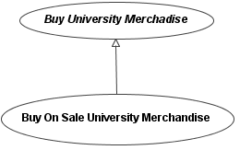
Use Case Name:

Buy On Sale University Merchandise
IMPLEMENTS Buy University Merchandise Online

Generalization between use cases example:
Use Case Name:  Buy University Merchandise Online | 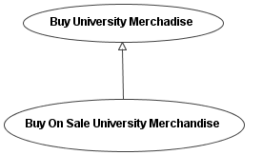
Use Case Name:

Buy On Sale University Merchandise
SPECIALIZES Buy University Merchandise Online

Generalization between actors example:

Actor Name:  Employee | 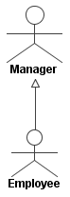
Actor Name:

Manager
SPECIALIZES Employee

Example Extension Points:

Use Case Name:  Buy University Merchandise Online | Use Case Name:  Product Out of Stock
Basic Flow:  {BEGIN Use Case}  .  .  {BEGIN select product}  actions  {END select product}  .  .  {END Use Case} | Extension Points:  PUBLIC EXTENSION POINT BEHAVIOR  EXTENDING { Buy University Merchandise Online : out of stock}  FLOW Basic Flow  AT {select product}  IF selected product is out of stock  {BEGIN out of stock}  actions  {END out of stock}  CONTINUE {browse merchandise catalogue}
Extension Points:

PUBLIC EXTENSION POINT
out of stock
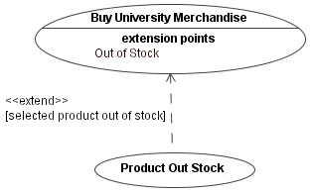

Keywords:

INCLUDE – used to show that an inclusion use case is now performed

Example:

In use case Buy Tickets:

Use Case Name:  Enroll New Member | 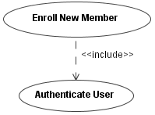
Basic Flow:

{BEGIN Use Case}
.
{BEGIN authenticate librarian}
- INCLUDE Authenticate User
{END authenticate librarian}
.
{END Use Case}

RESUME – used to show the next header that will be performed in the Basic Flow.
AFTER – used to state the headers that need to be completed first before the current header can be performed.

AT- used to state the header in the Basic Flow where a condition will be evaluated.

IF – used to state a condition.

BEGIN/ END – used to declare the start and end of a header.

PRIVATE EXTENSION POINT – used to describe the behavior of a private extension point

PUBLIC EXTENSION POINT – used to declare an open ‘port’ in the base use case where extended behavior will be inserted.

PUBLIC EXTENSION POINT BEHAVIOR – used at the extension use cases to describe the extended behavior.

FLOW – used to state the type of flow where the extended behavior will be inserted in the base use case.

CONTINUE – used to state the header in the base use case that will be performed next upon completion of the extended behavior in the extension use case

ABSRTACT – used to declare that the given use case is abstract.

IMPLEMENTS – used to state which abstract use case does that current use case implement.

SPECIALIZES – used to state which use case does that current use case specialize.

SUBFLOW- used to state a subflow name

PERFORM – used to show that a subflow is now performed

Example:

In use case Buy Tickets:

{BEGIN enter ticket order information}
- Customer→ selects the desired game from the team’s calendar
- Customer→ enters the desired section
- Customer→ enters the number of tickets
- Customer→ submits order request
- PERFORM search tickets
{END enter ticket order information}

Recall the Hockey Store System:

The requirements:

The system allows customers to purchase tickets for upcoming hockey games. To buy a ticket, a customer needs to choose the game he/she would like to attend from the team’s online calendar. The customer selects the desired section in an area where he/she would like their tickets to be along with the quantity of tickets requested. Upon retrieval of this information, the system will search the database for the requested tickets. If the tickets are available, the customer is prompted to either accept or reject the offered seats. If the customer accepts the offered seats, the customer is then directed to a billing page where the purchase transaction can take place. Otherwise, if the tickets are not available, the customer is informed about the unavailability and then requested to submit another search for tickets. Occasionally, tickets for certain games in certain sections of the hockey arena may go on sale. Unlike regular priced tickets, a customer may purchase a maximum of six on sale tickets. The system also allows customers to purchase team merchandise such as hockey jerseys, sticks, pucks…etc. When choosing a merchandise item, the customer may provide customization requests for an extra cost. Available customization options depend on the type of item. For example, if the item was a hockey jersey, the customer may choose to have his/her name sewed on the jersey along with their favorite number. Meanwhile, if the item was a steel pen, the customer may have a name (or other words) engraved on the pen. To boost merchandise sales, a customer may enter a ticket number while purchasing merchandise for a chance to win a grand prize. A customer may purchase tickets and team merchandise using a credit card or a team hockey card. If the customer chooses to purchase using a credit card, an external credit card authorization system is utilized to verify the validity of the given credit card information. Meanwhile, if the customer chooses to purchase using a team hockey card, the customer is requested to enter a PIN. The system internally verifies the PIN with the associated hockey team card to approve the transaction. For any purchase, the customer is requested to enter billing information. The billing information is used for market survey purposes and delivery of tickets and team merchandise. Billing information would include the customer’s name, phone number and address.

The Use Case Diagram:

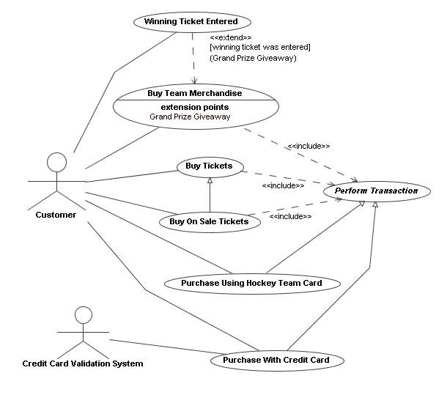

The Use Cases:

- Use Case Name:
Buy Tickets
Brief Description: This use case is responsible for allowing customers to purchase as many tickets as they need in any section.
Preconditions:
- At least one game and one seat is available
Basic Flow:

{BEGIN Use Case}

{BEGIN present price list}
- SYSTEM→ presents the different sections that exist in the arena and the price for a single seat in each section
{END Present Price List}

{BEGIN enter ticket order information}
- Customer→ selects the desired game from the team’s calendar
- Customer→ enters the desired section
- Customer→ enters the number of tickets
- Customer→ submits order request
- PERFORM search tickets
{END enter ticket order information}

{BEGIN purchase ticket}
- SYSTEM→ prompts the Customer to accept or reject the offered seats
- Customer→ accepts to purchase ticket
- INCLUDE Perform Transaction
{END purchase ticket}

{END Use Case}
Alternative Flows:

AT {enter ticket order information}
- PERFORM search tickets
IF tickets not available
{BEGIN search for tickets again}
- SYSTEM→ notifies the Customer that the requested tickets are unavailable
RESUME {enter ticket order information}
{END search for tickets again}

AT {purchase ticket}
- Customer→ accepts to purchase ticket
IF tickets were rejected
{BEGIN rejected seats}
- SYSTEM→ notifies the Customer that the cancellation has been confirmed.
RESUME {present price list}
{END rejected seats}
Subflows:

SUBFLOW search tickets
{BEGIN print new member’s record}
- SYSTEM→ retrieve seating information about the requested games
- SYSTEM→ retrieve seating information about the requested section
- SYSTEM→ locates the desired number of seats in the requested section. The seats must be next to each other in the same row
{END print new member’s record}
Postconditions: If tickets are issued, these seats become unavailable for future customers
Extension Points:
Special Requirements: System must be online

- Use Case Name:
Buy On Sale Tickets
SPECIALIZES Buy Tickets
Brief Description: This use case is responsible for allowing customers to purchase a maximum of six on sale tickets.
Preconditions:
At least one game and one seat is available
Basic Flow:

{BEGIN Use Case}

{BEGIN present price list}
- SYSTEM→ presents the different sections that exist in the arena and the price for a single seat in each section
{END present price list}

{BEGIN request on sale tickets}
- Customer→ indicates interest to purchase on sale tickets
- SYSTEM→ presents the selected games that have on sale tickets
- SYSTEM→ presents the selected sections that contain on sale tickets
{END request on sale tickets}

{BEGIN enter ticket order information}
- Customer→ selects the desired game with on sale tickets
- Customer→ selects the desired section with on sale tickets
- Customer→ enters the number of desired on sale tickets
- Customer→ submits order request
- PERFORM search on sale tickets
{END enter ticket order information}

{BEGIN purchase ticket}
- SYSTEM→ prompts the Customer to accept or reject the offered seats
- Customer→ accepts to purchase tickets
- INCLUDE Perform Transaction
{END purchase ticket}

{END Use Case}
Alternative Flows:

AT {enter ticket order information}
- PERFORM search tickets
IF tickets not available
{BEGIN search for tickets again}
- SYSTEM→ notifies the Customer that the requested tickets are unavailable
RESUME {enter ticket order information}
{END search for tickets again}

AT {enter ticket order information}
- Customer→ enters the number of desired on sale tickets
{BEGIN too many tickets}
- SYSTEM→ notifies the Customer that the requested number tickets exceed the maximum allowed of six
RESUME {enter ticket order information}
{END too many tickets}

AT {purchase ticket}
- Customer→ accepts to purchase ticket
IF tickets were rejected
{BEGIN rejected seats}
- SYSTEM→ notifies the Customer that the cancellation has been confirmed.
RESUME {present price list}
{END rejected seats}
Subflows:

SUBFLOW search on sale tickets
{BEGIN print new member’s record}
- SYSTEM→ retrieves seating information about the requested games
- SYSTEM→ retrieves seating information about the requested section
- SYSTEM→ locates the desired number of seats in the requested section. The seats must be next to each other in the same row
{END print new member’s record}
Postconditions: If tickets are issued, these seats become unavailable for future customers
Extension Points:
Special Requirements: System must be online

- Use Case Name:
ABSTRACT
Perform Transaction
Brief Description: This use case is responsible for allowing customers to pay for their selected items
Preconditions:
At least one ticket is requested for purchase
Basic Flow:

{BEGIN Use Case}

{BEGIN enter billing information}
{END enter billing information}

{BEGIN print receipt}
{END print receipt}

{END Use Case}
Alternative Flows:
Subflows:

SUBFLOW print receipt
{BEGIN print transaction information}
{END print transaction information}
Postconditions:
If tickets are issued, these seats become unavailable for future customers
If merchandise is sold, the merchandise database is updated
Extension Points:
Special Requirements: System must be online

- Use Case Name:
Purchase With Credit Card
IMPLEMENTS Perform Transaction
Brief Description: This use case is responsible for allowing customers to pay for their selected items using a credit card
Preconditions:
At least one item is requested for purchase
Basic Flow:

{BEGIN Use Case}

{BEGIN enter billing information}
- SYSTEM→ requests Customer to enter billing information
- Customer→ enters first and last names
- Customer→ enters phone number
- Customer→ enters billing address
- Customer→ selects to pay using a credit card
{END enter billing information}

{BEGIN pay by credit card}
- Customer→ enters credit card type
- Customer→ enters credit card number and expiry
- Credit Card Validation System→ validates given credit card
{END pay by credit Card}

{BEGIN print receipt}
- PERFORM print receipt
{END print receipt}

{END Use Case}
Alternative Flows:
Subflows:

SUBFLOW print receipt
{BEGIN print transaction information}
- SYSTEM→ prints Customer information
- SYSTEM→ prints credit card information
- SYSTEM→ print items information and total price
{END print transaction information}
Postconditions: If tickets are issued, these seats become unavailable for future customers
Extension Points:

PRIVATE EXTENSION POINT
FLOW Basic Flow
AT {pay by credit card}
- Credit Card Validation System→ validates given credit card
IF credit card information is incorrect
{BEGIN enter credit card information again}
- SYSTEM→ notifies the Customer that the credit card information is incorrect
{END enter credit card information again}
CONTINUE {pay by credit card}
Special Requirements: System must be online

- Use Case Name:
Purchase Using Hockey Team Card
IMPLEMENTS Perform Transaction
Brief Description: This use case is responsible for allowing customers to pay for their selected items using a preauthorized payment plan setup on their hockey team card
Preconditions:
At least one item is requested for purchase
Customer has a hockey team card with a set PIN
Basic Flow:

{BEGIN Use Case}

{BEGIN enter billing information}
- SYSTEM→ requests Customer to enter billing information
- Customer→ enters first and last names
- Customer→ enters phone number
- Customer→ enters billing address
- Customer→ selects to pay using a hockey team card
{END enter billing information}

{BEGIN enter team hockey card information}
- Customer→ enters team hockey team card number
- Customer→ enters card PIN
- SYSTEM→ verifies card number and PIN
{END enter team hockey card information}

{BEGIN print receipt}
- PERFORM print receipt
{END print receipt}

{END Use Case}
Alternative Flows:

AT {enter team hockey card information}
- SYSTEM→ verifies card number and PIN
IF card information is invalid
{BEGIN enter team hockey card information again}
- SYSTEM→ notifies the Customer that the team hockey card information is incorrect
RESUME {pay by credit card}
{END enter team hockey card information again}
Subflows:

SUBFLOW print receipt
{BEGIN print transaction information}
- SYSTEM→ prints Customer information
- SYSTEM→ prints team hockey card information
- SYSTEM→ print items information and total price
{END print transaction information}
Postconditions: If tickets are issued, these seats become unavailable for future customers
Extension Points:
Special Requirements: System must be online

- Use Case Name:
Buy Team Merchandise
Brief Description: This use case is responsible for allowing customers to buy team merchandise such as jersey, hockey sticks, mugs and other collectibles
Preconditions:
Basic Flow:

{BEGIN Use Case}

{BEGIN display catalogue}
- SYSTEM→ displays catalogue with all team merchandise items
{END display catalogue}

{BEGIN select items}
- Customer→ selects desired items to purchase
- Customer→ enters quantity of each item
- Customer→ enters any desired customization information
{END select items}

{BEGIN purchase items}
- INCLUDE Perform Transaction
{BEGIN a chance to win}
  - Customer→ enters a ticket number for a chance to win
{END a chance to win }
{END purchase items}

{END Use Case}
Alternative Flows:
Subflows:
Postconditions:
Extension Points:

PUBLIC EXTENSION POINT
Grand Prize Giveaway
Special Requirements: System must be online

- Use Case Name:
Winning Ticket Entered
Brief Description: This use case is responsible for the situation where a winning ticket was entered.
Preconditions:
Basic Flow:
Alternative Flows:
Subflows:
Postconditions:
Extension Points:

PUBLIC EXTENSION POINT BEHAVIOR
EXTENDING {Buy Team Merchandise : Grand Prize Giveaway}
FLOW Basic Flow
AT {a chance to win}
IF winning ticket was entered
{BEGIN grand prize giveaway}
- SYSTEM→ notifies Customer the he/she won the grand prize
- Customer→ enters phone number for a Customer service representative to call
{END grand prize giveaway}
CONTINUE {END Use Case}
Special Requirements: System must be online

