Exercise: Using the SUCD Structure to Describe UCs

Library System Requirements:

The system allows a new member to be enrolled into the library database. To enroll, the member must provide the Librarian his/her name, address and phone number. In order for the Librarian to enroll the new member, the Librarian must login to the system by providing his/her username and password. The system checks the username and password decides whether the Librarian should be granted access. Upon enrollment, the system creates a member ID for the new member and creates member card.
A member can borrow a book. In order for the member to borrow a book, the member must provide his/her member card. The Librarian must scan the member’s and the system will determine if that member has any overdue charges. If that member has overdue charges, the member is forbidden from borrowing anymore books until he/she has paid the overdue charges. In the normal case where there are no overdue charges, the librarian must enter the book’s name and checkout date into the system. The system provides a receipt that shows the member’s ID, the book’s name and the due date. Once again, in order for the Librarian to allow a book to be borrowed, the Librarian must successfully login to the system.

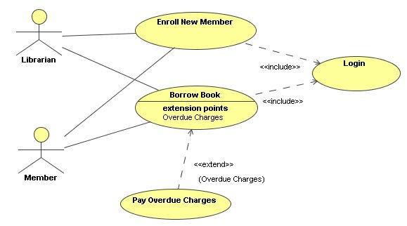

Remember to write a 1 or 2 sentence description from the actors too.

