Simple Structured Use Case Description (SSUCD)
User Guide

  - A Brief Introduction to the Elements of SSUCD

- Use Case Name Section:

The “Use Case Name” section states characteristic properties about a given use case. This section starts with the label “Use Case Name:”.

Structural elements and keywords:
- The name of the use case:
The “Use Case Name” section must state the name of the use case.

- If the use case is abstract:
This is stated using the keyword ABSTRACT. If the use case is not abstract then this keyword is omitted. On the other hand, if the use case implements an abstract use case, then this is stated using the keyword IMPLEMENTS. Similarly, if the use case does not implement any abstract use cases, then this keyword is omitted.

- If the use case specializes other use cases:
This is stated using the keyword SPECIALIZES. If the use case does not have any parents, then this keyword is omitted.

Mapping information and examples:
- The name of the use case:
The name stated in the “Use Case Name” section must have a use case symbol (an oval) in the diagram with a matching name (see Fig. 3.1).

Use Case Name:  Buy On Sale University Merchandise | 
Fig. 3.1: Use case name and its representation
- Abstract Use Cases and their Implementation:
The name of an abstract use case is displayed in italic font in the diagram. A use case implementing an abstract use case creates a generalization relationship arrow in the diagram, originating from the implementing use case and directed towards the abstract use case (see Fig. 3.2).

Use Case Name:  ABSTRACT  Buy University Merchandise | 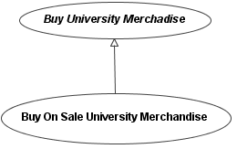
Use Case Name:

Buy On Sale University Merchandise
IMPLEMENTS Buy University Merchandise Online
Fig. 3.2: Abstraction and implementation in use cases and their representation
- Generalization Between Use Cases:
The use case name as specialized by a child use case creates a generalization relationship link between the involved use cases, originating from the child use case and directed towards the parent use case (see Fig. 3.3).

Use Case Name:  Buy University Merchandise | 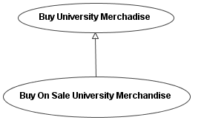
Use Case Name:

Buy On Sale University Merchandise
SPECIALIZES Buy University Merchandise
Fig. 3.3: Generalization between use cases its representation

- Associated Actors Section:

Actors are associated with use cases to perform the described behavior and to achieve a certain goal. Actors can be associated with use cases for various reasons. Each use case must specify the actors that are involved with it. The “Associated Actors” section is used to list the involved actors with only commas separating them.

Mapping information and example:
Actors listed in this section must have an association relationship link connecting the use case and the corresponding actors in the diagram (see Fig. 3.4).

Example:
Use Case Name:  Enroll New Member | 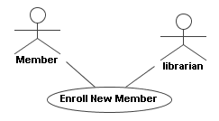
Associated Actors:
Librarian, Member
Fig. 3.4: Associations between use cases and actors and its representation
- Description Section:

The “Description” section contains the core behavior of the use case. As mentioned earlier, the “Description” section is intentionally designed to be populated using natural language to allow use case authors utmost flexibility with respect to describing their use cases. Another reason is to minimize the amount of learning required by the users of SSUCD. If an author requires to add a new section, the new section is simply written using natural language as part of the “Description” section.

Structural elements and keywords:
There is only one keyword in this section which states that the given use case includes another use case. An include relationship is stated using the keyword INCLUDE followed by the name of the inclusion use case enclosed in angled brackets “INCLUDE <inclusion use case name>“.

Mapping information and example:
An INCLUDE statement present in the “Description” section of a use case creates an include relationship link originating from the base use case and directed towards the inclusion use case stated in the INCLUDE statement (see Fig. 3.5).

Use Case Name:  Enroll New Member | 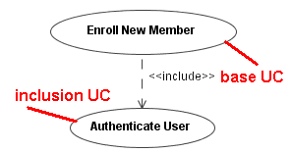
Description:
… before a new member can be enrolled, INCLUDE <Authenticate User> must be performed to authenticate the staff …

Fig. 3.5: The include relationship represented in the use case description body
- Extension Points Section and Extended Use Cases Section:
The “Extension Points” section lists all the public extension points that belong to the given use case. Although there are two types of extension points; public and private, only public extension points appear on the use case diagram. Hence, private extension points can be described using natural language within the Description “section” without the need to add further structure. The “Extended Use Cases” section lists all the use cases that the given use case extends.

Structural elements and keywords:
- The Extension Points Section
Base use cases that are extended should not have any knowledge of their extension use cases. Base use cases only provide public extension points for extension use cases to specify the locations where the extended behavior will be inserted. This is because base use cases are expected to be complete even without the incorporation of the extension use cases. Public extension points listed under an “Extension Points” section are separated using carriage return.

- The Extended Use Cases Section
Conversely, extension use cases are expected to have knowledge of the base use cases they extend. The “Extended Use Cases” section lists the base use cases that the given use case extends. An extended use case is stated using the keyword “Base UC Name:” followed by its name. If an extension use case extends a base use case at a given public extension point, the extension point is stated using the keyword “Extension Point:” followed by the name of the public extension point. Therefore, using the “Extension Point” construct is optional since stating a public extension point for a given extend relationship is optional. If a condition needs to be set for the extend relationship, this is stated using the keyword “IF” followed by the condition written in natural language. Specifying a condition for an extend relationship is optional. Hence, using the “IF” construct is also optional (see Fig. 3.6).

Example:
Use Case Name:  Buy University Merchandise Online | 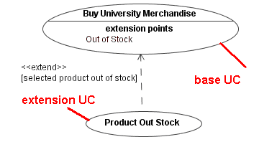
Extension Points:

out of stock

Use Case Name:

Product Out of Stock
Extended Use Cases:

Base UC Name: Buy University Merchandise Online
Extension Point: out of stock
IF selected product is out of stock
Fig. 3.6: The extend relationship represented in the use case description body.

