Consistency Rules for Mapping SSUCD Use Cases to Use Case Diagrams

The following template will be used to present information about mappings between use case description structures and use case diagrams (see Table 1):
Table 1. Template for mapping description structures to diagrammatic elements
Use Case Description Structure Element:
Description of how to map a description structure element to use case diagrammatic notation(s).
Example:
An example of the use case description structure element and its corresponding diagrammatic notation(s).
Consistency Rules:
A set of consistency rules that are used to check the consistency between any given set of descriptions and their corresponding diagrams(s), which will be required by a tool if analysts decide to build the use case diagram before writing the use case descriptions.

- Use Case Name:

Example:
Use Case Name:  Buy On Sale University Merchandise | 

Consistency Rules:
- A use case description with a given use case name generates a use case in the diagram with a matching name.
- Every use case description must have a corresponding use case in the diagram with matching names
- Every use case in a diagram must have a corresponding use case description with matching names

- The INCLUDE Statement:

Example:
Use Case Name:  Enroll New Member | 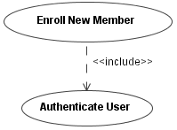
Description:

…INCLUDE <Authenticate User>…

Consistency Rules:
- An inclusion use case in a diagram must be initiated at least once by each base use case that includes it, using the include statement in the Description section.
- An INCLUDE statement in a base use case must refer to a use case that exists in the diagram
- An INCLUDE statement in a base use case results in an include relationship link between the base use case and the extension use case.

- Public Extension Points:

Example:
Use Case Name:  Buy University Merchandise | 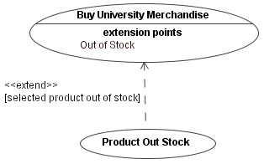
Description:
…
Extension Points:
Out of stock
Use Case Name:

Product Out of Stock
Extension Points:

Base UC Name: Buy University Merchandise
Extension Point: Out of Stock
IF selected product out of stock

Consistency Rules:
- At the base use case, any depicted public extension points must be stated under the Extension Points section.
- At the extension use case, the Base UC Name must state the name of a use case that exists in the use case diagram.
- The use case name indicated under the Base UC Name section must be connected to the given use case in the use case diagram using an extend relationship.
- The extension point stated in the Extension Point Section must exist at the base use case stated in the Base UC Name section stated right above it.
- If an ‘IF’ statement is used, the condition stated must be depicted as a UML condition in the use case diagram as part of the extend relationship link.

- Associations Between Actors and Use Cases:

Example:
Use Case Name:  Enroll New Member | 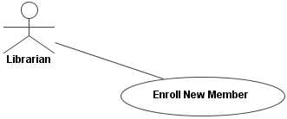
Associated Actors:

Librarian

Consistency Rules:
- An actor must be depicted in the diagram.
- An actor must be linked with that use case using an association relationship in the diagram.

- Generalization Between Use Cases:

Example:
Use Case Name:  Buy University Merchandise Online | 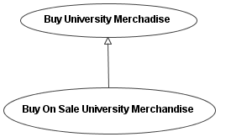
Use Case Name:

Buy On Sale University Merchandise
SPECIALIZES Buy University Merchandise Online

Consistency Rules:
- A use case name stated as generalized in another use case’s Use Case Name section creates a generalization relationship link between the involved use cases.
- A specializing use case must refer to a different use case that exists in the diagram
- A specializing use case must refer to a use case in the diagram that is specializes.
- The specializing use case must have a generalization relationship directed towards the generalized use case in the diagram

- Abstract Use Cases and their Implementation:

Example:
Use Case Name:  Buy University Merchandise Online | 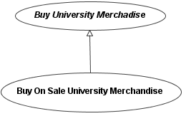
Use Case Name:

Buy On Sale University Merchandise
IMPLEMENTS Buy University Merchandise Online

Consistency Rules:
- The name of an abstract use case is displayed in italic font in the diagram. A use case implementing an abstract use case creates a generalization relationship arrow in the diagram, originating from the implementing use case and directed towards the abstract use case.
- An implementing concrete use case must refer to an abstract use case that exists in the diagram.
- An implementing concrete use case must refer to an abstract use case that it implements.
- The entire header tree structure of the abstract use case must exist and be implemented in the concrete use case.
- A use case description written in abstract form (italics) must have a corresponding use case in the diagram with its name displayed in italics.
- An abstract use case in the diagram must have a corresponding use case description written in abstract form (italics).

- Generalization Between Actors:

Example:
Actor Name:  Employee | 
Actor Name:

Manager
SPECIALIZES Employee

Consistency Rules:
- An actor name stated as generalized in another actor’s Actor Name section creates a generalization relationship link between the involved actors.
- A specializing actor must refer to a different actor that exists in the diagram
- The specializing actor must have a generalization relationship directed towards the generalized actor in the use case diagram.
- Every actor description with a given name must have a corresponding actor in the diagram with a matching name.
- Every actor in the diagram with a given name must have a corresponding actor description with a matching name.

